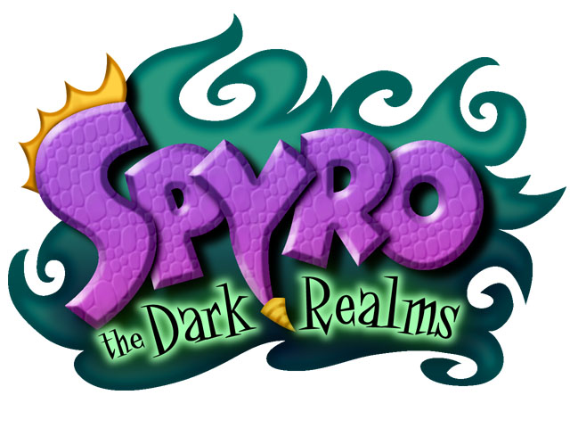

Level Walkthrough

Realm 1-C

Dragonfly Falls

Updated: July 15th 2004

CONTENTS
REALM 1 C – DRAGONFLY FALLS 3
REFERENCE 3
Visual Elements / Features 3
GAME TASKS 4
Light Gem Tasks 4
Dragon Egg Tasks 4
Dark Gem Tasks 4
SUMMARY OF TASK LIST ENTRIES 5
NEW ABILITIES AVAILABLE TO SPYO AT START OF LEVEL 6
NEW ABILITIES GAINED DURING THE LEVEL 6
NEW ABILITIES REQUIRED IN THE LEVEL (at some point) 6
GRAPHICAL ASSETS 7
Objects / Interactive Elements 7
NPC’s 7
Enemies 7
Traps & Hazards 8
Playable Characters 8
Containers & Collectables 8
Power-ups 8
START OF THE LEVEL 9
Explore the early areas in linear order. 9
Dark Gem (1) & Dragon Egg (1) 9
Fodder 10
Encounter the Mountain Goats 10
The first Light Gem. 10
Restart Point 10
The Perilous Chasm 10
Dark Gem (2) 11
Reaching the Dragon Egg 11
ACCESS TO SECRET AREA 11
Waterfall leap 11
Bat Cave 11
TIME FOR SWIM 12
Dark Gem (3) 12
Access to Sparx Shooter 12
The Waterfall 12
Dragon Egg in the cave 12
Swimming area 12
HUNTERS AREA 13
NPC DIALOGUE: Hunter 13
Hunter’s Task 13
NEARING THE END 13
Wall Kick to Light Gem 13
Dark Gem (4) – Open Shortcut 13

REALM 1 C – DRAGONFLY FALLS

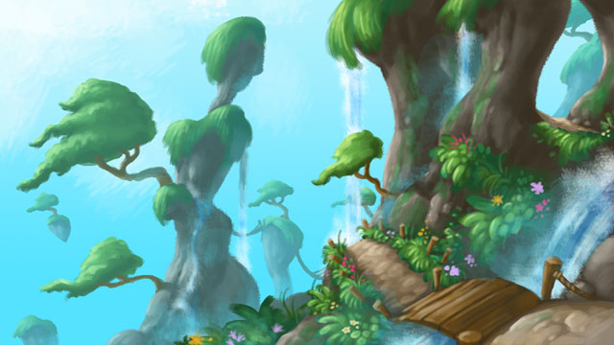

This area takes place around cliffs and caves and has many platform areas with suspended outcrops of land and floating mounds of earth. It then leads to a coastal area where waterfalls crash down through dramatic rock formations and floating rock islands. Over time, the waters have carved tunnels and shallow caves into the cliffs and the misty air supports a variety of giant plants.

REFERENCE

MOVIES

GAMES

JAK & DAXTER
- Geyser Rock

Visual Elements / Features

GAME TASKS

Light Gem Tasks

- Inside Locked Chest
- Use Cannon to open cave
- Bat Cave in Secret Area
- Dive into water cave (behind Dark Gem waterfall pool)
- In Locked Chest behind palm-tree.
- Complete Hunters area.
- Use Wall Kick to reach high ledge
- On the Buoy (use rafts to cross Shark infested waters).
- Sparx Mini-game (Hard)

Light Gems (Total) = 9

Dragon Egg Tasks

- Behind Dark Gem.
- Vultures Nest
- Egg Thief
- Use Wall Kick
- Hunters Area
- Sparx Mini-game (Easy)

Dragon Eggs (Total) = 6

Dark Gem Tasks

- Dark Gem 4: Opens up ceiling letting in light to destroy vines around egg.
- Dark Gem 2: Remove black gunk from around the Cannon
- Dark Gem 3: Unseal waterfalls into water cave leading to Light Gem.
- Dark Gem 4: Remove twisted piece of craggy rock to create shortcut.

Dark Gems (Total) = 4

SUMMARY OF TASK LIST ENTRIES

- Hunter to retrieve the Dragon Egg
  - Check conditions = Hunter collected Dragon Egg

- Hunter to find the Light Gem
  - Check conditions = Hunter collected Light Gem

NEW ABILITIES AVAILABLE TO SPYO AT START OF LEVEL

Spyro will have access to the following abilities when entering this level for the first time. He will not necessarily need to use all of these abilities within the level.

Note: This list does not include the default basic set of moves that Spyro has at the beginning of the game.

Abilities
- Double Jump / Horn-dive
- Pole Spin

Gadgets Switched On
- Ball Gadget

NEW ABILITIES GAINED DURING THE LEVEL

Spyro can gain these abilities during this level so he can either proceed within the level or gain access to further areas in the future.

New Abilities
NONE

NEW ABILITIES REQUIRED IN THE LEVEL (at some point)

These are the abilities that are needed at some point in this level that Spyro will gain in the future. At various times during the game Spyro can come back to this level with a new ability and use it to complete certain tasks.

New Abilities
- Double Jump / Horn-dive
- Pole Spin
- Wall Kick

Gadgets
- Ball
- Aqualung

New Breath Types
- Ice

GRAPHICAL ASSETS

Objects / Interactive Elements

- Gadget Activation Pad – (for Ball Gadget)
- Cracked Wall (Charge)
- Branches & Bramble (similar to the vines & weeds)
- Horn-dive Switch (on floor)
- Floating Platform (raises after pressing switch)
- Cannon
- Reinforced Steel Door (use Cannon to destroy)
- Cracked Wall 1 (Charge)
- Restart / Teleport Pad
- Teetering Platforms
- Raising / Lowering platforms
- Black Gunk (covering Cannon – so it can’t be used)
- Rock Column (with Cannon sat on top)
- Rock Column (sat on top of platform to be shot away)
- Nest (with Dragon Egg inside)
- Thermal (to carry Spyro back up a great height)
- Horn-Dive Boulder

NPC’s

- Zoe (Save Position)
- Professor’s (head) Hologram – on Gadget Activation Pads.
  - Ball Gadget
- Sparx
- Hunter

Enemies

- Mountain Goat
- Shepherd
- Piranha
- Vulture (perched / swooping)
- Vulture (circling / dropping rocks)
- Tree Dweller (reserved for Secret Area).
- Shark (for when Spyro goes too far out to sea)
- Gnorc Sentry
- Gnorc Archer (used only in Hunter area)
- Crocovile

Traps & Hazards

- Spike Traps

Playable Characters

- Hunter

Containers & Collectables

- Basic Chest
- Metal (Charge) Chest
- Horn-dive Chest
- Locked Chest (requires Sparx Lock-picker Power-up)
- Dragon Egg

Power-ups

- Spyro – Ammo for Secondary Fire (Flame Breath)
- Spyro – Ammo Magazine for Secondary Fire (increase capacity)
- Spyro – Horn-dive Concussive Blast Radius
- Spyro – Double Gem Value (limited time)
- Sparx – Lock-pick (open Locked Doors and Chests)
- Sparx – Keychain to hold 3 Lock-picks.
- Sparx – Extra Hit (Red status)
- Sparx – Health Replenish (Jar of Butterflies)
- Shop Teleport Ticket

Power-ups to switch on when get appropriate Breath.
- Spyro – Ammo for Secondary Fire (Electric Breath)
- Spyro – Ammo for Secondary Fire (Water Breath)
- Spyro – Ammo for Secondary Fire (Ice Breath)

MAIN MAP

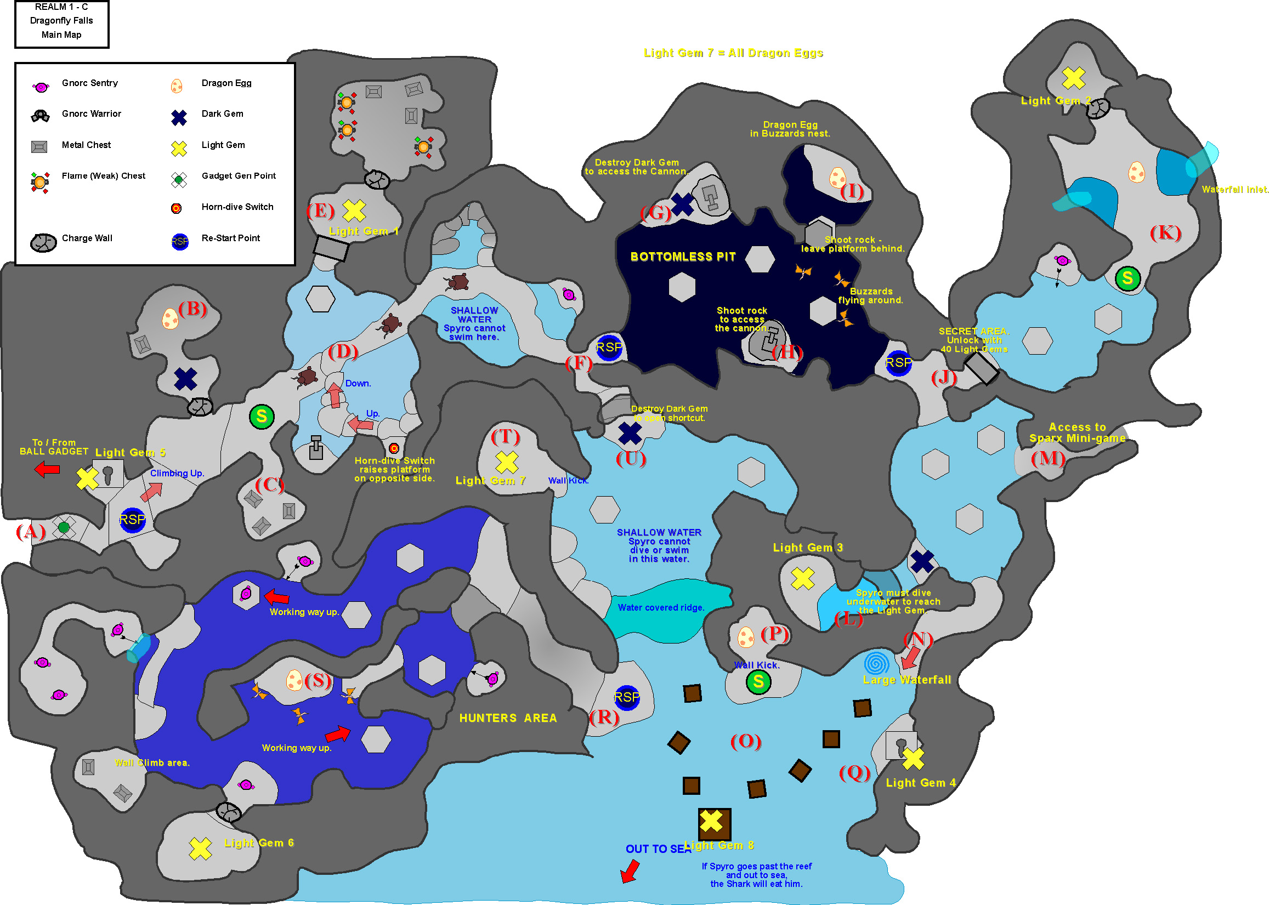

START OF THE LEVEL

Explore the early areas in linear order.

Spyro starts this area near the Gadget Generation pad after getting out of the Ball Gadget (A).

Climbing up a series of ledges and past a couple of Gnorc Sentries, and can see a ledge nearby that houses a Locked Chest containing a Light Gem.

Spyro will come to a cave, concealed behind a cracked wall. Charging this allows access to the cave containing loads of treasure (C). This is a one off situation, the cracked wall will not re-trigger after the game has been saved. The Chests within the cave will not re-trigger once the contents have been collected.

Dark Gem (1) & Dragon Egg (1)

Spyro will come to a cave guarded by a Gnorc Sentry. Charging at the cracked wall leads into the cave and onto the first Dark Gem of this level (B).
Destroying the Dark Gem causes the ceiling to open up and light shines through onto gnarly vines covering the Dragon Egg. The vines wilt away allowing access to the Dragon Egg.

Fodder

In the open area outside the caves, there is plenty of fodder (sheep) for Spyro to recover his health if he is low after fighting the Gnorc Sentries.

Encounter the Mountain Goats

As Spyro proceeds, he comes across some narrow ledges that hug the canyon wall and occasionally open out into areas with water pools below (D). Blocking the path is a large boulder that will be destroyed by a bad-tempered Mountain Goat. (This gives the player a clue that boulders can be destroyed using the Horn-dive move).

The Mountain Goat(s) must be Charged or Flamed to get past.

Spyro can fall off the ledges of the bridges into the shallow water pools below. There may be some secret stuff down there such as hidden gems but it means a climb back up.

The first Light Gem.

Near the first narrow ledge (D) and halfway up the steps is a Horn-dive switch that Spyro must activate to bring a platform into view. Nearby is a cannon sat on a high ledge. This can be used to blow open the reinforced barrier on the other side. Beyond the barrier (E) there is a Light Gem and a concealed cave containing treasure.

Restart Point

Continuing through the narrow canyon Spyro will encounter Vultures that fly from posts towards him and must be flamed or charged to defeat.

There are also further Mountain Goats in this area that are commanded by a Shepherd to attack Spyro in two’s.

Further along the narrow bridge Spyro will reach a Re-start Point (F).

The Perilous Chasm

After the Restart Point, the canyon opens out into a large (seemingly) bottomless chasm. Spyro must traverse a series of moving platforms over this chasm while avoiding attacks from the circling Buzzards/Vultures. Some platforms are precariously resting on spiked rocks and will teeter as Spyro lands on them so he should avoid standing on the extreme edges and putting too much weight on one side. Other platforms will rise and lower requiring clever timing on Spyro’s jumps.

Dark Gem (2)

Spyro must figure out how to reach the 2 cannons/turrets stationed on platforms at either side of the canyon. The first cannon is immobilised by more of the strange black substance and Spyro must destroy the Dark Gem (G) nearby to access the cannon.

Reaching the Dragon Egg

This cannon can then be used to destroy a rock column that has another cannon sat on top. When the rock is destroyed the cannon (H) will fall to the ground. Spyro must use the cannon to take out circling Vultures that drop boulders when above Spyro’s head. Spyro must then destroy another column (releasing concealed gems) and create a platform to reach the other side. Spyro’s reward is a Dragon Egg (I) that the Vultures have been keeping in their nest.

Once across the other side of the chasm, Spyro can register at another Re-start point (J), before passing into the tunnel.

ACCESS TO SECRET AREA

Spyro will come across a Vault Door that can only be opened once Spyro has collected 70 Light Gems.

Waterfall leap

Spyro can make a series of jumps up a shallow stream fighting Gnorcs along the way. If Spyro falls off the platforms down into the shallow water he will be pursued by a couple of aggressive Gnorc Warriors. At the end of the platform sequence Spyro must jump through a waterfall to progress further and reveal a room (K) containing a Dragon Egg on a bridge. When Spyro approaches the Dragon Egg, an Egg Thief will appear and steal the egg (and becomes a Egg Thief pursuit).

Bat Cave

Upon further inspection, this area also has a secret cave hidden behind a concealed wall that can be smashed using the Charge move. Inside this cave is a long-lost hoard of valuable gems and a Light Gem.

The cave is guarded by bats that can be seen hanging from the ceiling.
The bats will attack Spyro has he approaches and must be flamed or charged to defeat.

After collecting the Light Gem, Spyro can drop off the ledge to collect more treasure from below then use a thermal to get back to the top.

TIME FOR SWIM

Dark Gem (3)

Coming back out of the secret area (J), Spyro must now make a leap across guarded platforms to an inlet (L) containing a Light Gem.
To reach the Light Gem, Spyro must destroy a Dark Gem to unblock waterfalls and fill the pool. He must then dive down into the deep pool on the other side of the platform and past the low overhanging roof.

Access to Sparx Shooter

The next cave along the cliff face is in near darkness and the entrance is very narrow (M). This cave can only be navigated by Sparx.

The Waterfall

Battling past Gnorcs posted on ledges, Spyro comes to the top of the waterfall (N) where he can jump from to the waters below.

Dragon Egg in the cave

There are two ways to get to this Dragon Egg (P). One requires a bit of forethought and must be done right first time. While on top of the waterfall, Spyro must jump out around the cliff and stay close to the cliff face while gliding around to the cave ledge. Failing this, Spyro can return later when he has the Wall-Kick ability, where he can jump from side to side between two facing walls to reach the top.

Swimming area

Most of the water in this lower area (O) is quite deep and infested with Piranha’s and Sharks.

There is a Locked Chest nearby (Q) that is blocked by a Palm tree. Accessing the chest reveals a Light Gem.

HUNTERS AREA

On the lower ledge there is a welcome Restart Point (R) and up on a higher ledge is Spyro’s old pal, Hunter. Hunter with his long distance Jumping abilities and Sniper Bow is the only one able to navigate the next area (S).

NPC DIALOGUE: Hunter

Hunter says that the area behind him cannot be accessed by Spyro. Hunter will have to go into the mountain to retrieve any items in there.

Hunter’s Task

Hunter enters a deep chasm (S) with the addition of sneaky cave dwellers that fire projectiles at any trespassers. Hunter must use his Bow and Arrow’s (more accurately in 1st Person Sniper mode) to take out the enemies from a distance and then proceed across a series of platforms separated by large distances. Each platform is higher than the last, so only Hunter’s extra jump height can achieve this over Spyro’s long distance glide (but inability to gain enough height). This area contains another Dragon Egg and a Light Gem. Hunter then returns to the entrance of the chasm and passes control back to Spyro along with his hard earned goodies.

TASK LIST ENTRY

- Hunter to retrieve the Dragon Egg
- Hunter to find the Light Gem

NEARING THE END

Wall Kick to Light Gem

Spyro must climb up a group of steep steps and ledges and then use his Wall-kick ability to reach a Light Gem (T).

Dark Gem (4) – Open Shortcut

Spyro must jump across a series of teetering platforms and destroy the Dark Gem (U) to remove a barrier (a twisted piece of craggy rock) which then leads him back out near the narrow mountain pass (F).

